Spatio Temporal Analysis Toolbox

User’s Guide

Last revision: September 2006

Contact: Frederic.Brochard@lpmi.uhp-nancy.fr

CONTENTS

- Preliminaries

- Overview of the Graphical Interface

- Computing Spectra

- Computing Bicoherence

- Other functions

- Annexes: list of the main variables

Note: This manual aims at helping you using the STA Box. It is not its purpose to describe the techniques used in the analyses. If you’re looking for information about wavelets or bicoherence, the following references are recommended:

B. Ph. van Milligen, Wavelets in Physics, Chapter entitled “Wavelets, non-linearity and turbulence in fusion plasmas”, Ed. J. C. van der Berg, Cambridge University Press, (1999) ISBN 0-521-59311-5.

B. Ph. van Milligen, Wavelet bicoherence: a new turbulence analysis tool, Phys. Plasmas 2, 3017 (1995).

U. Greb and M. G. Rusbridge, The interpretation of the bispectrum and bicoherence for non-linear interactions of continuous spectra, Plasma Phys. and Control. Fusion 30, 537 (1988).

D. Grésillon and M. S. Benkadda, Direct mode-mode coupling observation in the fluctuations of nonstationary transparent fluid, Phys. Fluids 31, 1904 (1988).

1) PRELIMINARIES

A) Requirements

To run the STA Box, you need MATLAB 6.5 (or a higher version), as well as the WAVELET Toolbox for MATLAB.

B) What is the STA Box ?

The STA Box provides a set of functions dedicated to Spatio-Temporal Analysis. Besides the classical spectral functions, it contains more advanced tools, such as bicoherence analysis for investigation of nonlinear coupling, Empirical Modal Decomposition (EMD) or Phase Portrait for dynamical studies, PDFs reconstruction etc… EMD as well as several kinds of Wavelets make it especially suitable for the analysis of non stationary data, chaos, weak and strong turbulence.
Functions can be used alone directly in the MATLAB command line, or more easily with the STA Graphical Interface (recommended, not only for the “beginners”).

C) Installation – Using the Graphical Interface

Unzip the archive in the folder of your choice, then run MATLAB and select the directory where you copied the files. To launch the STA Graphical Interface, type “sta” in the MATLAB command line. That’s all!

D) I don’t like the Graphical Interface, I prefer the command line

Well, it’s your decision, but in that case don’t tell me, ‘cause I would be disappointed having spent time in developing the Graphical Interface (GI)… Since some functions are rather complex (especially all the bicoherence functions), it is strongly recommended to use the GI as long as you don’t understand how the functions are written in order to avoid ‘exotic’ results.
To use the functions directly in the command line, the first step, of course, is to know what is done by which function. Here is a short list by categories:

Spectral Analysis Functions
Fourier Frequency Power Spectrum: fspecFou.m
Fourier Wavenumber Power Spectrum: kspecFou.m
Fourier 2D Spectrum: spec2.m
Two-points Spectra (frozen flow hyp.): twopspec.m
Wavelet Frequency Power Spectrum: fspec.m
Wavelet Wavenumber Power Spectrum: kspec.m
Hilbert Spectrum: coming soon!
Hilbert-Huang Spectrum (EMD-based): coming soon!

Bispectral Analysis (Bicoherence)
Fourier Frequency Bicoherence: coming soon!
Fourier Wavenumber Bicoherence: coming soon!
Wavelet Frequency Bicoherence: wbicw.m
Wavelet Wavenumber Bicoherence: kbictot.m
Movie showing the evolution of the k-bicoherence: kbicmov.m

Other functions
EMD decomposition: coming soon!
Phase Portrait Analysis: coming soon!
PDF reconstruction: pdf.m

Typing “help + name_of_the_function” in the command line will provide a short description of the function as well as an example (identical to the header of the m-files). Moreover, (a few) comments can be found in the m-files themselves (Good luck!).

2) OVERVIEW OF THE GRAPHICAL INTERFACE

(a) (b) (c) (d)
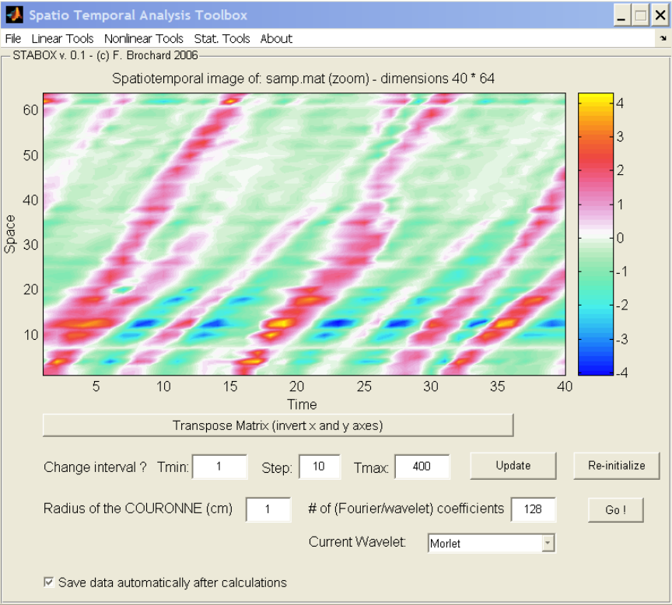

(e)

(f)

(g)

(h) (i) (i)

(j)

- Well, I suppose everybody can guess what this menu contains: the more important is that it is the place where you select and upload the .mat files which are used for the calculations.

- This menu contains functions for linear analysis: essentially all kinds of spectral analysis, but also Empirical Modal Decomposition and Phase Portrait analysis.

- Here you will find everything about bicoherence analysis

- This menu is dedicated to statistical analysis. For the moment, it only contains a function for constructing the Probability Distribution Function (pdf) of a signal.

- This window shows the data under analysis. The title indicates the name of the current file, the size of the corresponding matrix (e.g. 40*64 here), and indicates if we analyze the complete data or only some part of it (“zoom”).

- By default, the program considers that the first column of a 2D array corresponds to the time, and the 2nd column to the space coordinate. If it is not the case, you can invert both dimensions by pushing this button (which is invisible in the case of 1D data).

- VERY IMPORTANT: it is here that you define which time interval you want to analyze. Since some operations require long time calculation (k-bicoherence especially), it is very convenient to reduce the interval where the analysis is performed. Once you defined your interval, it is necessary to push the “UPDATE” button to make the changes effective. The figure showing the data is then refreshed, and its title indicates the new size of the matrix. Note that you can at any time go back to the original interval by pushing the “Re-initialize” button.

- This part contains several buttons and dialog boxes which depend on the current operation, and which allow to define the parameters of the analysis. Read the description of the operations for details.

- Pushing this button runs the calculations for the selected interval and parameters. Results are displayed in separate figures.

- Select this checkbox before running the calculations if you want to save the output data. Data will be saved in structured .mat files in the current directory with the following names:
- foufspec / foukspec Fourier Frequency/Wavenumber spectra
- wavfspec / wavkspec Wavelet Freq/Wavenumber spectra
- fkspec 2D Fourier (w/k) spectrum
- wavfbic / wavkbic Wavelet Freq/Wavenumber bicoherence
- PDF don’t you guess ;o) ??
Moreover, any time that data are saved you are noticed by a message in the command window, which gives the name of the new file. The possibility of choosing the name of the output files will be provided later…

3) COMPUTING SPECTRA (menu “linear tools”)

  - Fourier Frequency Spectrum (fspecfou.m)

A classical one…

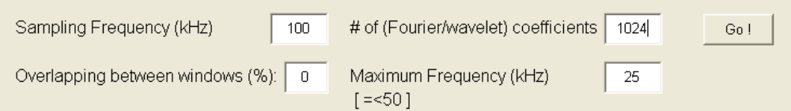

You can adjust 4 parameters:

- the sampling frequency, in kHz

- the number of Fourier coefficients. The default value is proportional to the length of the time series, but you can of course choose another value (should be a power of 2 nevertheless). Is it necessary to tell that a high value improves the accuracy but requires more calculations and thus more time?

- The overlapping (in %) between the windows used by the algorithm. Default is zero, it is useful to increase it (e.g. => 50%) when the time series are short, since it allows using more FFT coefficients, leading to a better accuracy at low frequencies.

- The maximum frequency shown in the spectrum, for saving calculation time and for a more readable figure in the low-frequency range. The maximum allowed is the Nyquist frequency, and the default value is set to half of the Nyquist Frequency.

This function can be used with 1D time series, as well as with 2D (Space * Time) arrays. In that case, the function averages the spectra over space.

If the “autosave” option is selected, data are saved in the foufspec.mat file, which is structured as follows:

foufspec.spec: values of the spectrum
foufspec.freq : frequency axis

  - Fourier Wavenumber Spectrum (kspecfou.m)

Based on the same routine as the Fourier Frequency Spectrum, the only difference is that the sampling frequency is replaced by the radius of the circular probe array, and the maximum frequency by a maximum wavenumber. The radius has to be entered in centimeters.

This function is available only with 2D matrices. In order to obtain an instantaneous k-spectrum, reduce the time interval to 1 (set tmin = tmax, step = 1), otherwise the k-spectrum will be averaged over time.
If the “autosave” option is selected, data are saved in the foufspec.mat file, which is structured as follows:

foukspec.spec: values of the spectrum
foukspec.kaxe: wavenumber axis

Tip: if the radius is set equal to 1, the k-spectrum will be shown as a function of the (dimensionless) mode number m, otherwise it will be shown as a function of k, in cm⁻¹.

  - Fourier F/K Spectrum (spec2.m)

For now it is only a basic application of the FFT2 matlab function. Only 2 parameters are available, i.e. the sampling frequency and the radius of the probe array. The possibility of using overlapping will be provided later (maybe).

If the “autosave” option is selected, data are saved in the fkspec.mat file, which is structured as follows:

fkspec.spec : values of the spectrum
fkspec.freq : frequency axis
fkspec.m : mode number axis

  - Wavelet Frequency Spectrum (fspec.m)

The main difference with the Fourier analysis is that you will obtain the time evolution of the frequency spectrum, in addition to the time averaged spectrum.
The parameters are the same as for the Fourier frequency spectrum, except that the overlapping option is replaced by a menu where you can select the wavelet function used for the analysis:

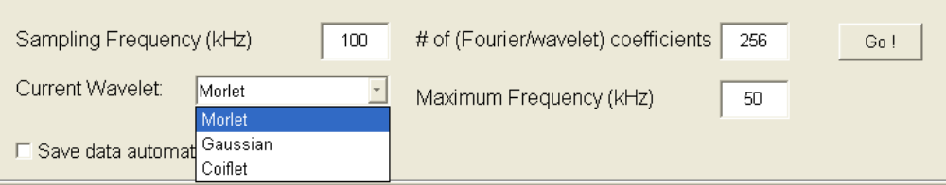

For now, only 3 wavelets are available (should be sufficient). Morlet and Gaussian wavelets offer a good compromise between frequency and time resolution. They are well suited for studying regular regimes, chaos, and weak turbulence (probably the best choice in 99% of your studies). The Morlet wavelet is the more commonly used in plasma physics. The Coiflet is a good wavelet for analyzing strong turbulence, but will lead to inaccurate spectra (especially at low scales) in all other cases.

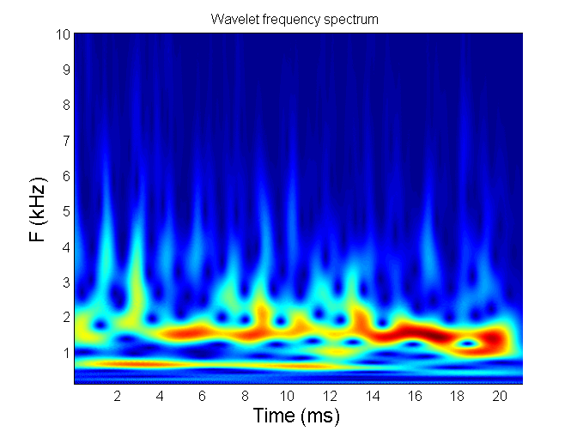 | 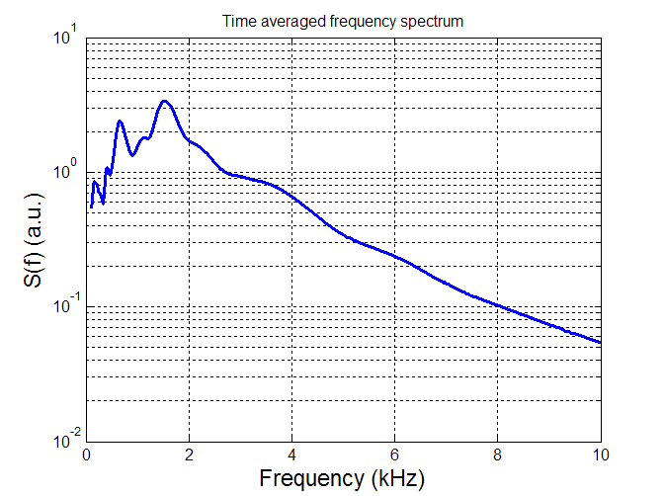
Example of wavelet frequency spectra obtained with STA (file serie.mat, analysis done using a Morlet Wavelet with 512 coefficients, S.F. 100 kHz, maximum frequency set to 10 kHz)

This function can be used with 1D time series, as well as with 2D (Space * Time) arrays. In that case, the function averages the spectra over space.

If the “autosave” option is selected, data are saved in the wavfspec.mat file, which is structured as follows:

wavfspec.spec : values of the spectrum at each instant, dimension [t, f]
wavfspec.avspec : time averaged spectrum
wavfspec.time : time axis
wavfspec.freq : frequency axis

  - Wavelet Wavenumber Spectrum (kspec.m)

It offers the same choice of parameters as the Wavelet Frequency Spectrum, the sampling frequency being replaced by the radius of the circular array, and the maximum frequency by the maximum wavenumber.

This function is available only with 2D matrices. In order to obtain an instantaneous k-spectrum, reduce the time interval to 1 (tmin = tmax, step = 1), otherwise the k-spectrum will be averaged over time.

If the “autosave” option is selected, data are saved in the wavfspec.mat file, which is structured as follows:

wavkspec.spec : values of the spectrum at each instant, dimension [t, k]
wavkspec.avspec : time averaged spectrum
wavkspec.time : time axis
wavkspec.kaxe : wavenumber axis

4) COMPUTING BICOHERENCE (menu “nonlinear tools”)

  - Fourier Frequency Bicoherence

To be included!

  - Fourier Wavenumber Bicoherence

To be included!

  - Wavelet Frequency Bicoherence (wbicw.m)

Since the main ingredient needed for the calculation of the bicoherence is a spectrum, you will find here the same parameters as for the Wavelet frequency spectrum. The result is shown in two separate figures. The first one shows the time averaged autobicoherence in the bispectrum plane F₁/F₂. The second one shows the time averaged frequency spectrum (up) as well as the summed bicoherence (bottom), where the statistical noise is indicated by a pink dotted line.

If the “autosave” option is selected, data are saved in the wavfbic.mat file, which is structured as follows:
wavfbic.b2 : Autobicoherence matrix, dimension [f1, f2]
wavfbic.f1ax : f1 axis
wavfbic.f2ax : f2 axis
wavfbic.sumb : Summed bicoherence
wavfbic.serr : Error on the summed bicoherence
wavfbic.fax : f axis of the summed bicoherence

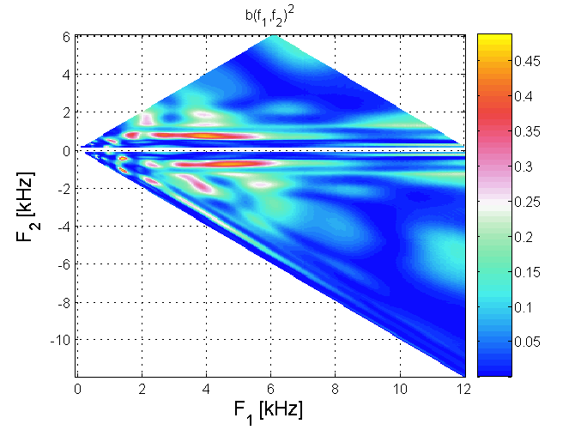 | 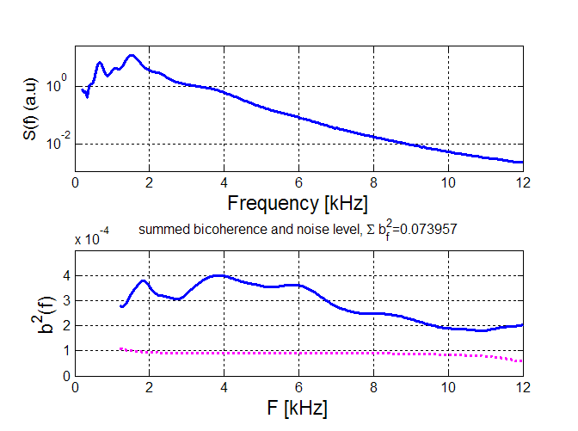
Autobicoherence in the (f1/f2) plane. | Frequency power spectrum (up) and summed bicoherence (down). The statistical noise is indicated by the dashed line

Good information on the calculation and on the interpretation of the wavelet bicoherence can be found in the following paper: B. Ph. Van Milligen et al., Phys. Plasmas 2, 3017 (1995).

  - Wavelet Wavenumber Bicoherence (kbictot.m)

Parameters for the wavelet wavenumber bicoherence are the same as for the wavelet wavenumber spectrum, as it can be seen in this figure:

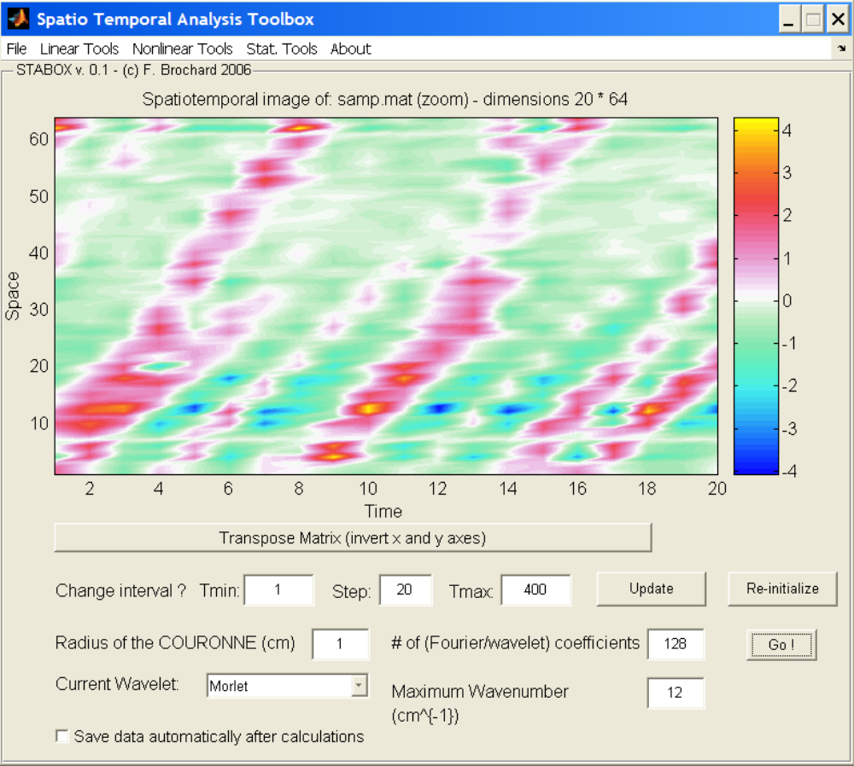
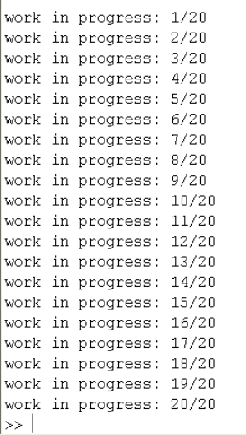

Since the calculation of the wavelet wavenumber bicoherence and of its time evolution can take some time, the progression is shown in the command line in order to help you estimate how long it will take (and to keep patience!):

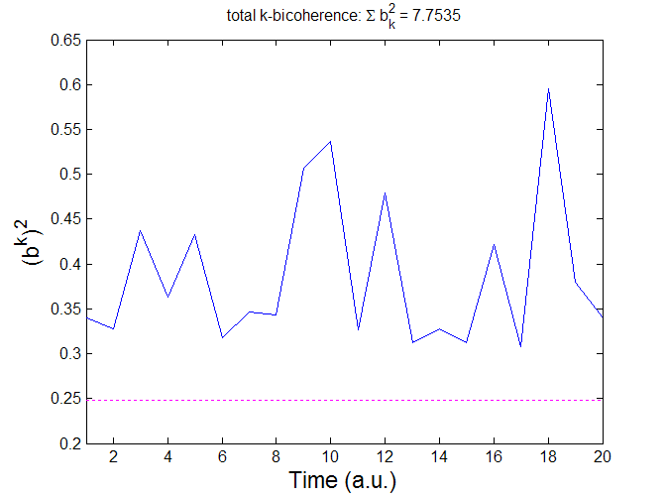
Normally, when finished, you should obtain two or three separate figures:

If you performed an analysis over at least 10 time instants, the first figure will show the time evolution of the total bicoherence (as well as the reference noise level, represented as usual by a pink dashed line).

In every case, you will also obtain the time averaged autobicoherence in the (k₁, k₂) plane, as well as the time averaged summed bicoherence (with the now traditional noise level, represented by a pink dotted line):

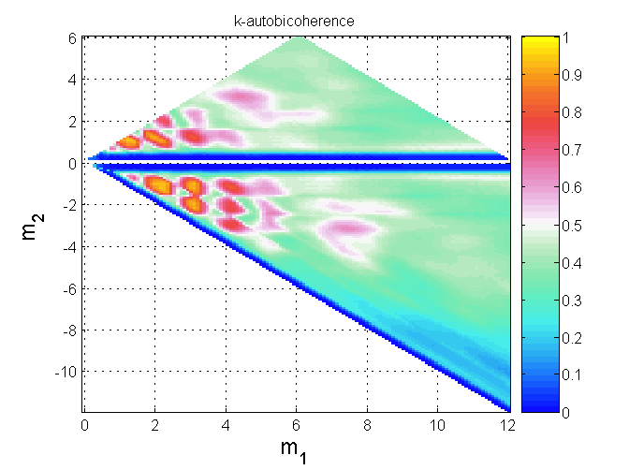 | 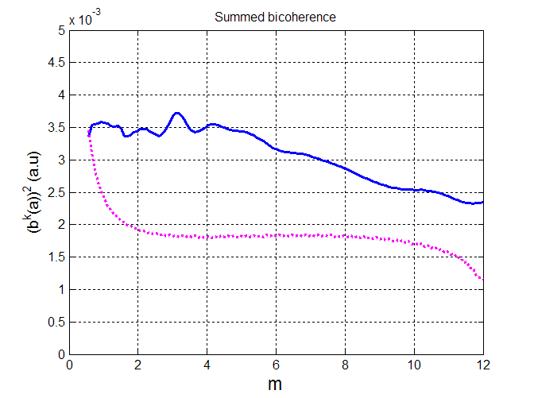
Autobicoherence in the (k₁, k₂) plane. | Time averaged summed bicoherence, with noise level.

If the “autosave” option is selected, data are saved in the wavkbic.mat file, which is structured as follows:

wavkbic.btot : time evolution of the total bicoherence
wavkbic.t : time scale for the total bicoherence (length t)
wavkbic.b2 : autobicoherence matrix, dimension [k1, k2]
wavkbic.k1ax : k1 axis
wavkbic.k2ax : k2 axis
wavkbic.sumb : summed bicoherence
wavkbic.serr : error on the summed bicoherence
wavbic.kax : k axis of the summed bicoherence
wavkbic.btime: autobicoherence matrix at each instant, dimension [t, k1, k2]
wavkbic.spectime: wavelet wavenumber spectrum at each instant, dimension [t, k]
wavkbic.sumbtime: summed bicoherence at each instant, dimension [t, k]

  - Wavenumber Bicoherence: movie (kbicmov.m)

If you used the “autosave” option before performing a wavenumber bicoherence analysis, this tool gives you the possibility of realizing easily a movie displaying the time evolution of the data. All you have to do is to select the name of the bicoherence data file in the dialog box (e.g. ‘wavkbic.mat’), and to give a name for the movie (by default, ‘kbicsum.avi’).

You will obtain a movie showing the time evolution of the total bicoherence (on the left) and the time evolution of the k-spectrum and summed k-bicoherence:

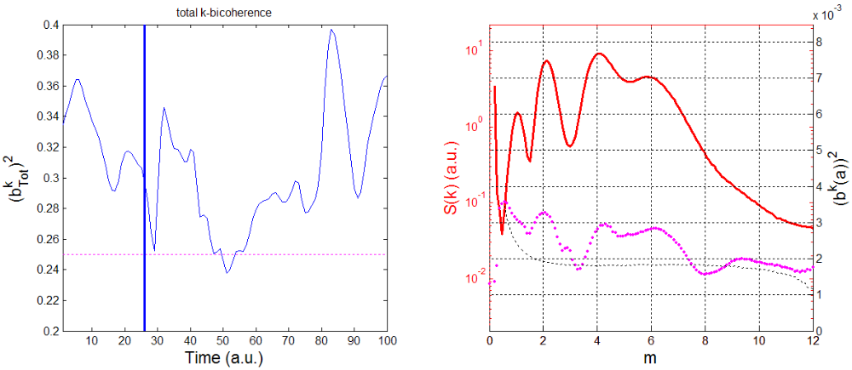
The movie shows on the left the time evolution of the total k-bicoherence (the vertical line shows the time progression), and on the right the k-spectrum (red) and the summed k-bicoherence (pink) at the same time (the noise for the summed bicoherence is represented by the dashed lines).

Such a movie is very useful for characterizing the effects of the coupling on the spectrum at a given modenumber.

5) OTHER FUNCTIONS

Coming soon!

6) ANNEXES: LIST OF THE MAIN VARIABLES

This section will detail the main variables used in the different m-files, in order to help you understanding and modifying them.

